PRACTICE DOCUMENT FOR

MAINTAINING STANDARDS IN

PRESCRIBING AND

ADMINISTERING OF DRUGS

Name:

Date:

NICU Practice document: prescribing and administering of drugs.
July 2013

Authors: Risk Management Team
Practice Development Team
Neonatal Unit Pharmacist

Introduction

The purpose of this document is to clarify issues around drug prescribing and administration and thereby enhance practice. It has been put together as a learning package for both medical and nursing staff in Neonatal Services.

It has been compiled in response to prescribing and administrative incidents reported via the risk reporting system. Examples used are taken from actual incidents that have occurred within the service, however examples have been modified to maintain confidentiality.

The document recognizes a need for back up revision following medical and nursing induction. It aims to assess your knowledge and competence regarding drug prescribing and administration and to clarify areas needing further education.

All staff will be given the document following their induction. It will need to be completed and returned within two weeks for marking. Please hand it to Ruby Lopez (Neonatal Nurse) for marking. Medical staff will be expected to take it to their first Consultant appraisal for discussion.

We hope you find this a useful tool.

- a) Why is the dose calculator sheet an important safety tool?

b) When should dose calculator sheets be updated?

- What is the significance of the purple apron when prescribing, preparing and administering drugs in neonatal services?

- What are the standard drug administration times on the NICU for:

- BD doses

- TDS doses

- QDS doses

- Oral supplements of vitamins, Sytron, Sodium, Potassium

4) a) What is the drug prescribing policy for NICU / SCBU?

b) What location on the unit (NICU) should all medication be written up?

c) What time of the day should most medication be written up?

5) List 5 aspects of this prescription which contravene the Addenbrooke’s Good Prescribing Guide and could lead to an error on the NICU:

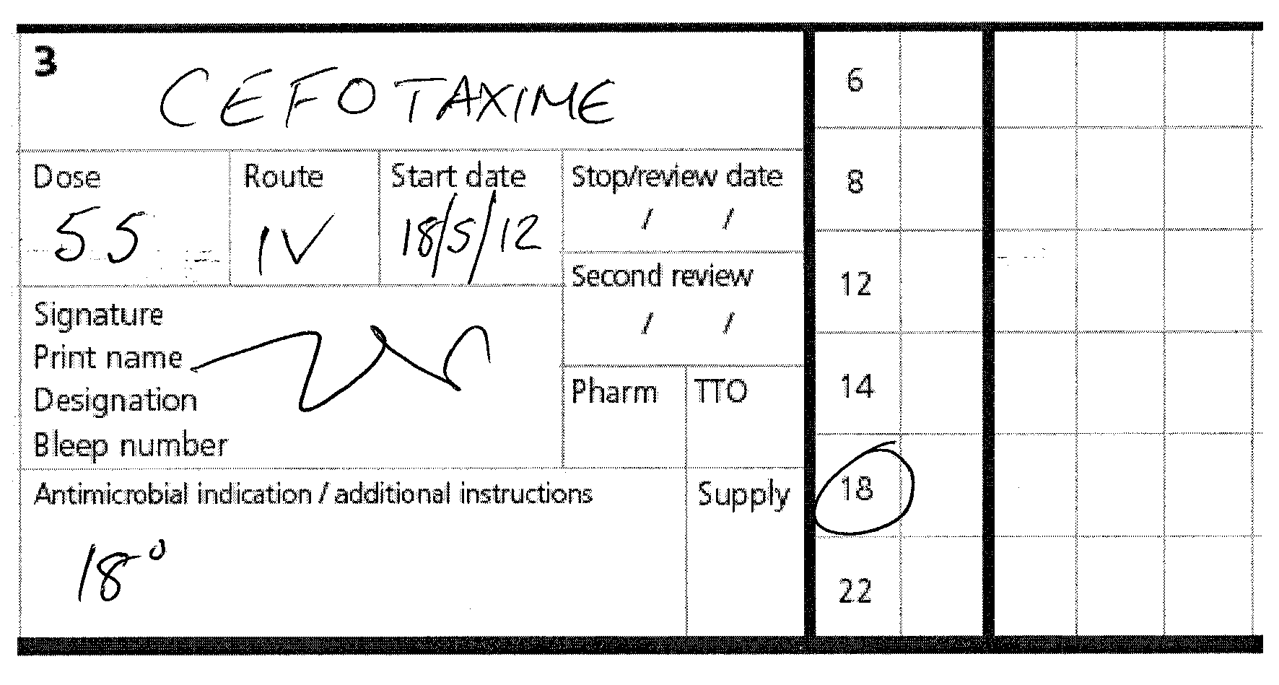

6) If you were responsible for administering this prescription what other information would you expect to see?

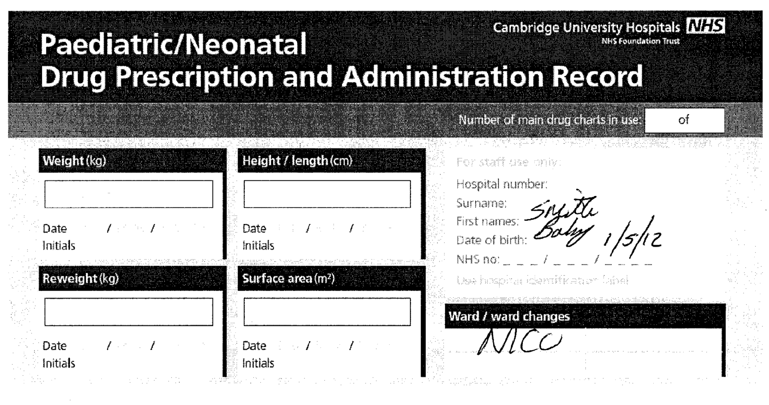

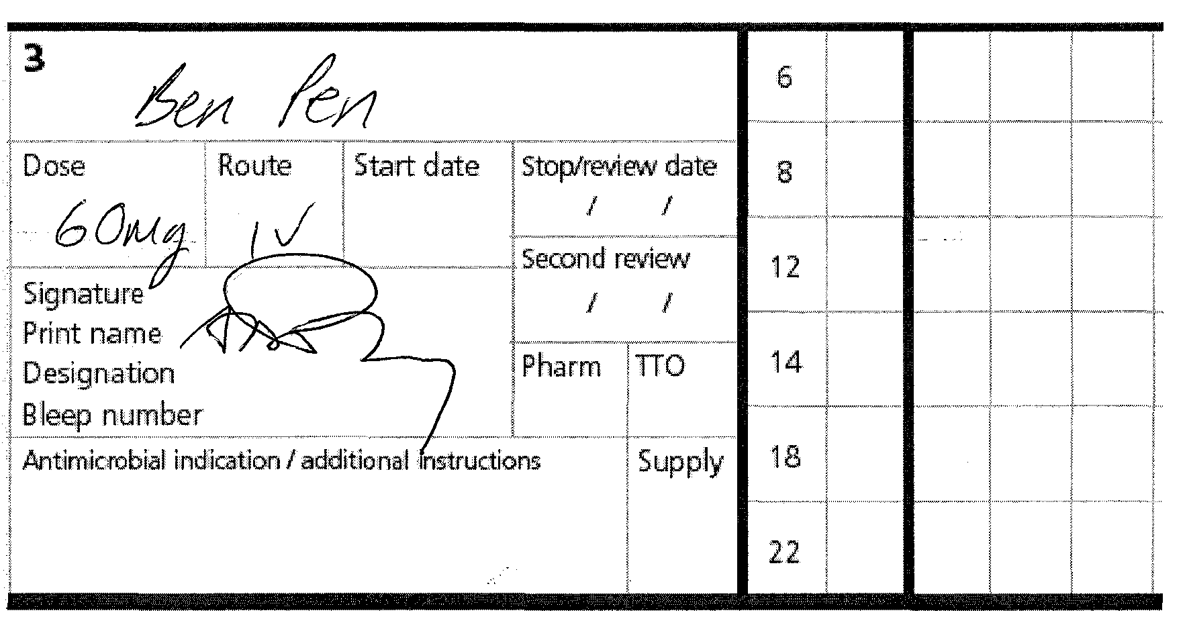

7) What 3 things should you expect to do / see when a prescription is cancelled?

8) Why should original prescriptions not be amended?

9) What action should be taken if the frequency of a drug changes after 2 doses?

10) When is the word “stat” acceptable on a drug chart?

11) When should maintenance dosing of caffeine be commenced following a loading dose?

12) a) Baby Smith weighs 700g and requires a loading dose of Caffeine Citrate. The first dose is to be given on 3 January 2003 at 17h00. Prescribe this on the drug chart provided, followed by a maintenance course of caffeine.

b) Baby Smith receives a loading dose of caffeine and one maintenance dose when it is noted that the documented birth weight details are incorrect. The correct weight is 750g. Show the necessary changes you would make to the prescription chart.

13) On which charts would you expect to prescribe a continuous vancomycin infusion and gentamicin doses?

14) When should levels be taken once an infant has commenced a Vancomycin infusion?

15) When should levels be taken on Gentamicin?

16) a) The first dose of Gentamicin is prescribed and given to a term baby with no concerns about renal function at 16h20 on 14 June. When is the first level due?

- When is the second dose due?

- When is the third dose due?

d) What needs to be checked before administering gentamicin?

e) What action would you take if there is a discrepancy from the gentamicin double checking prompt?

17) For a continuous vancomycin infusions what actions should be taken if Vancomycin levels are?

a) <10mg/l -

b) 10 to <15mg/l -

c) 15 to 25mg/l -

d) > 25 to 30mg/l -

e) >30mg/l -

18) Where should 18 hourly drugs OTHER than Vancomycin and Gentamicin be prescribed?

19) An infant, Baby Brown born at 26/40 (DOB 01.01.12) weighing 750g is to be treated with a continuous vancomycin infusion. There is no indication of renal impairment and his creatinine is <50micromol/L. Using the drug charts attached (see appendices) prescribe the loading dose which would be due to be given at midnight on 03.01.12. What would the Vancomycin maintenance dose and infusion rate be?

20) What drugs is a continuous infusion of Vancomycin incompatible with?

21) Prescribe 2 doses of Gentamicin for the same baby with the first dose due to be given at 2pm on 02.01.12 (see appendices).

22) If a drug dosage needed changing after 2 doses, how would you amend the prescription?

23) Baby Brown weighing 750g is diagnosed with a PDA. The decision is made to treat with ibuprofen IV. Prescribe this drug on the attached drug chart with the first dose to be given at 18.00hrs on 08.01.03.

24) What would you monitor prior to and following administration of ibuprofen?

25) What is the correct dose of Morphine / kg:
a) As an infusion?

b) As a loading dose?

26) Where can you find information on prescribing Morphine?

27) Baby Brown requires a morphine loading dose and subsequent continuous infusion. If she weighs 750g prescribe a morphine loading dose and infusion on drug and infusion charts provided. The loading dose (100 microgram / kg / dose) is to be given at 1pm on 08.01.03 followed immediately by a standard continuous infusion (diluent is dextrose 10%).

28) Baby Brown needs to be fluid restricted. Re prescribe the Morphine infusion at double strength.

29) A decision to wean Baby Brown off Morphine is made following a good post op recovery. Paracetamol is prescribed to maintain pain relief as needed. Prescribe this on the attached chart accordingly.

30) What is the correct dose of Metronidazole / kg for a baby that is 45 days old:

31) Baby Brown is being treated for suspected NEC. Prescribe a course of Metronidazole.

32) Prescribe hydrocortisone for an 800g infant for the management of hypotension.

33) Prescribe an insulin infusion for a baby who weighs 930g, where the normal insulin prescription range has not proven to be effective.

34) Baby Brown weighing 750g requires 3mmols / kg / day of Sodium and 2mmols / kg / day of Potassium adding to his 10% Dextrose. He is on 120mls / kg of fluid. Calculate his requirements and prescribe these as you would expect to see them on the fluid chart provided.

35) Where would you go for guidance if you needed information relating to the prescription or administration of a drug / infusion?

36) What would you do if you noted a discrepancy between the monograph and the handbook?

37) List 10 things you would check on a prescription prior to administering a drug.

