ANSWERS TO THE WORKBOOK ON SAFER PRESCRIBING FOR PAEDIATRIC DOCTORS.

What does this answerbook contain?
This book contains the answers to the workbook you completed before induction.

During the induction prescribing session you will compare your answers to the model answers provided. Additional information on drug errors is also provided in this answerbook.

Where do I go to get more information?
Please feel free to approach any of the paediatric pharmacists. You may also find it useful to discuss incidents and prescribing practice with your colleagues.

PRESCRIBING MEDICATION FOR CHILDREN

The Trust Prescribing Guidelines MUST be followed when prescribing medication.

The general rules for prescribing are: -

  - Use an addressograph to ensure that the patients Name, Hospital number and Date of Birth are on the prescription.

  - Ensure that the child’s weight is written on the prescription. If a weight is amended it is good practice to date the new weight.

  - The Drug Allergies box MUST be completed, even if the child has no allergies. It is also useful to include details of any food allergies.

  - Approved generic drug names MUST be used, with the name written in Capitals.

  - Correct dosage units MUST be used. Write micrograms in full (rather than mcg or μg), and also write nanograms in full.

  - DO NOT use Roman numerals when prescribing.

  - Do not use abbreviations. E.g. write Potassium Chloride in full and not as KCl.

  - Prescriptions for liquid medicines MUST have the dose written by weight of the drug (in milligrams, micrograms etc), and not prescribed just as mls.

  - For PRN drugs the maximum frequency must be indicated.

  - Ensure that when the use of a decimal point is unavoidable, that the decimal point is clear and where relevant, that the decimal point is preceded by a zero e.g. Dalivit 0.6ml not .6ml.

  - If a change needs to be made to a drug, the drug must be rewritten in full again and the original prescription crossed out, signed and dated.

  - When rewriting charts ensure that the start date of the drug is carried forward (particularly for defined courses of medication).

  - All antibiotics should have an indication and a completed stop / review date (which should be acted upon in a timely fashion)

Exercise 1
- The errors noted on Page 1 of the chart are:

Patient details unclear (first name v. surname): should be addressograph

Weight not dated
- Allergies not completed

Using an addressograph gives additional patient identifiers (address, NHS number). This can be critical if there are patients with similar names admitted at the same time.

The weight must be dated – particularly for long stay patients and those with big weight changes. The units are also important. Incidents have occurred where the wrong weight units have been used (e.g Drugs prescribed on a weight of 7.4kg, whereas the child actually weighs 7lbs 4oz – 3.3kg). In addition make sure that the correct weight is written on the correct patient’s drug chart.

Allergies are a common cause of complaint and litigation and an accurate drug history must include a record of the patient’s current allergy status.
________
In the next 5 pages, each prescription from the medication chart is reproduced, along with a list of the errors demonstrated and an example of how to correctly prescribe.
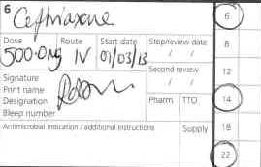

- Original:

The errors on this prescription are:
- The drug name should be in capitals
- Do not use unnecessary zeros. This prescription could potentially be misread as 5000mg instead of 500mg
- The dose units could be written clearer, to ensure the dose is administered correctly as 500mg
- Incorrect frequency. Ceftriaxone is a ONCE daily dose
- The indication and review date for the antibiotic are not stated
- The doctor’s signature is unclear and should also include a printed name and bleep number
For a bonus mark: IV flushes should be prescribed when a patient is on any IV medication. This ensures the right flush is used (0.9% saline or hepsal depending on the type of line) and allows the nurses to accurately record what is given to each patient. The volume given to a small infant may be a significant contribution to their fluid balance if on frequent IVs. The first page of the chart has pre-printed sections for flushes. Just add the volume required, frequency, date and sign as usual.
Another pre-printed prescription prompt: Oxygen is a drug and should always be prescribed. The section is on the ‘as needed’ page. Please add target saturations and any other useful information e.g. Needs medical review if FiO₂ >50%.

The ten times overdose
This is a common and potentially very damaging cause of error. Ceftriaxone, like many other drugs, could lead to renal / liver damage. Macrolide antibiotic overdoses could also lead to hearing loss.
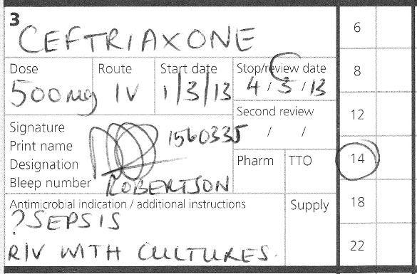
Correct prescription:

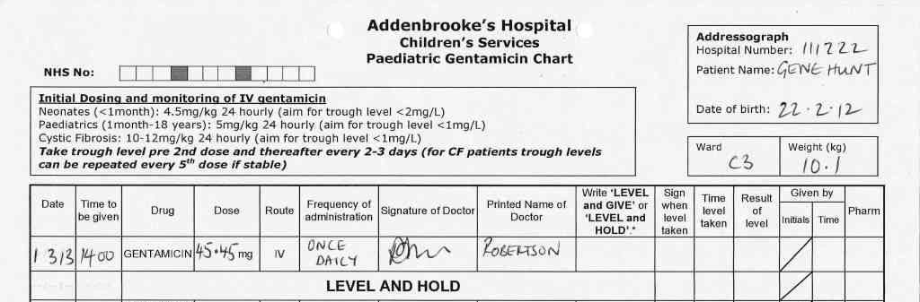
- Original:

The errors on this prescription are:
- As this child is 12 months old the correct dose is 5mg/kg, not 4.5mg/kg
- Unneccessary decimal places can be confusing and lead to administration errors. It is also not possible to measure volumes this accurately when drawing up the drug. Round to a sensible number, in this case 50mg.
- Date and time of the gentamicin level should be completed, or this may be missed leading to significant delays in treatment.
- The antibiotic review date has not been completed.
- The doctors signature is unclear and should also include a printed name and bleep number.
Drug Levels
Gentamicin, vancomicin and tobramicin all need therapeutic levels monitoring when geiven intravenously. To make the prescription clearer they are all prescribed on separate chart which should be attached to the main drug chart. Each drug also has a colour-coded cross-referencing sticker which should be stuck onto the regular prescriptions page of the main drug chart.
- Gentamicin – pink
- Vancomicin – blue
- Tobramicin – green
Either the sticker or the coloured chart should have the indication and review / stop date added to it.
Review the dose and instructions for timing of levels at the top of each chart.
Prescribe all the doses until the next level is due. If you only prescribe one dose then subsequent doses are highly likely to be delayed.
If the patient has a central line, through which the drug is administered, ensure the line is not used to take blood for levels as contamination can easily occur.
Other drug levels which may be monitored are phenytoin, phenobarbitone and caffeine. Most levels are ‘trough’ or pre-dose, but if unsure then speak to the lab or a pharmacist.
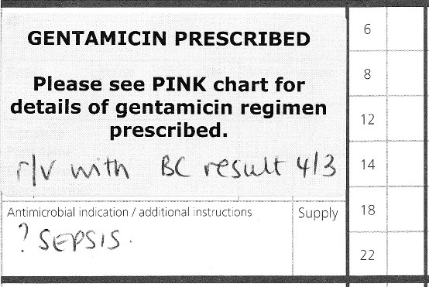

Correct Prescription:

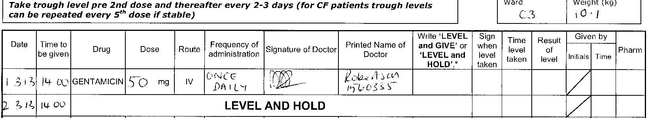
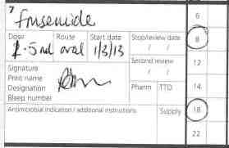

- Original:

The errors on this prescription are:
- The drug name should be in capitals and also use the rINN (recommended International Non-proprietary Name), in this case FUROSEMIDE.
- The dose is not clear. If any amendments are made the prescription must be crossed out and written in full again.
- Doses should be prescribed in terms of the solid dosage (e.g mg, microgram). Most drugs should not be prescribed in mls.
- The doctors signature is unclear and should also include a printed name and bleep number.
Dosage units.
In this case the use of mls could have resulted in a variety of doses being administered to the child as furosemide liquid is available in different strengths from 20mg/5ml to 50mg/5ml and there are a variety of other non-standard strengths which some patients may be receiving.
When checking a drug history always ask if the parents/carers have the medication and check the strengths of any liquids they may be administering.

Amending prescriptions
Do not amend prescriptions. Cross them out and start again, remembering to sign, print name, and date all prescriptions that are crossed out.
In this case is the prescription could be for 1.5ml or 2.5ml. This is an obvious source of confusion, and if the nursing staff gave the wrong dose, you would not have a leg to stand on.
Amending the original prescription also causes problems when reviewing patients as it becomes very hard to see when the change was made, and how many doses the patient has received at the new dose.
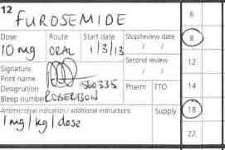
Correct Prescription:

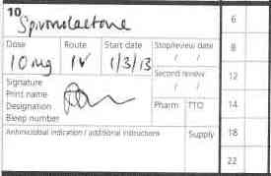
- Original:

The errors on this prescription are:
- The drug name should be in capitals
- No frequency
- Spironolactone is not available as an IV preparation and if the patient cannot tolerate using the oral route at present potassium canrenoate should be used instead.
- The doctors signature is unclear and should also include a printed name and bleep number.

Not all routes are equal
Patients may have oral medications switched to the intravenous route for several reasons, including pre- or post-op, nausea and vomiting and intubation / ventilation.
Some drugs, such as spironolactone, do not have an intravenous preparation and an alternative must be given. Other drugs do come in an oral and intravenous preparation but the dose used is different. Always check in the BNFc and if you are not sure, speak to a pharmacist.
Multi-route prescribing must also not be used for any regularly prescribed drugs, as the drug chart will not allow the details of the route to be documented for each dose administered. The chart would therefore not be provide an accurate record of drug administration to the patient and could be challenged medico-legally.
The drugs which most commonly cause confusion in this regard are paracetamol, spironolactone, ranitidine and anti-epileptics.
Be especially wary prescribing IV paracetamol. Because we use the oral dose so frequently it is easy to be complacent. Both the IV and oral dose vary with age.
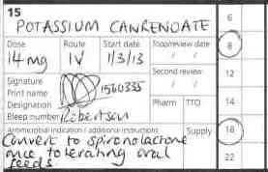
Correct Prescription:

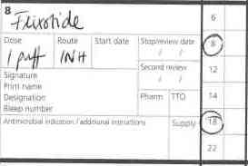
- Original:

The errors on this prescription are:

a) The drug name should be in capitals and using generic names (FLUTICASONE).
b) No inhaler strength has been specified.
c) The prescription has no start date
d) There is no signature, printed name or bleep number-

Prescribing inhalers: -

Because there are so many combinations of inhaler device & strength, it means that taking a correct medication history becomes very important. If you are not sure then do not guess. You can ask the advice of the pharmacist who can speak to the parents to find out more about the inhaler type, or the GP surgery can be contacted to check the medication that has previously been prescribed.

Correct Prescription: 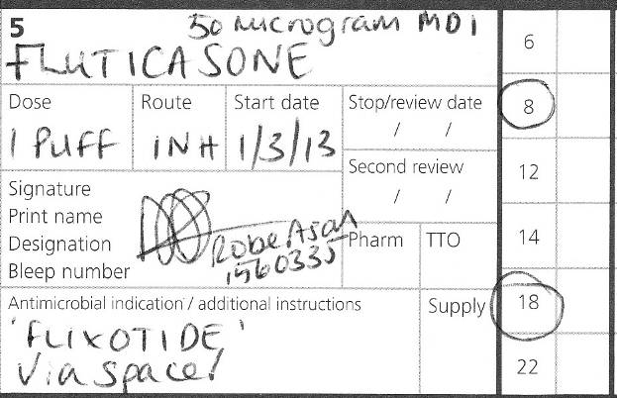
Exercise 2 - Prescribing medication on admission
The following chart show how the patient’s own drugs should be prescribed.
The key points were: -
- Changing drug names to generic names
- Including inhaler strength for Beclometasone
- Changing the Sodium Valproate dose to mg, rather than ml.
- Combining the dose of lamotrigine into 1 prescription, rather than having 1 prescription for 25mg bd, and a second prescription for 5mg bd.

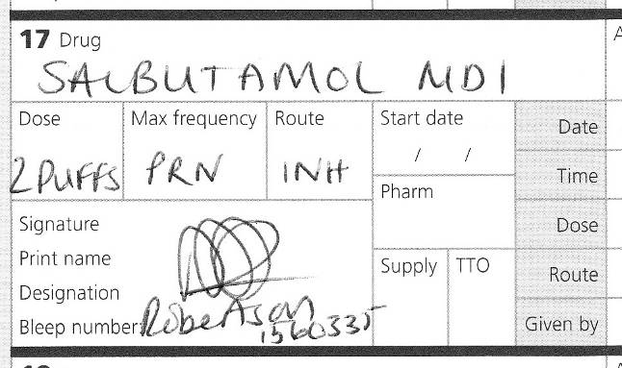
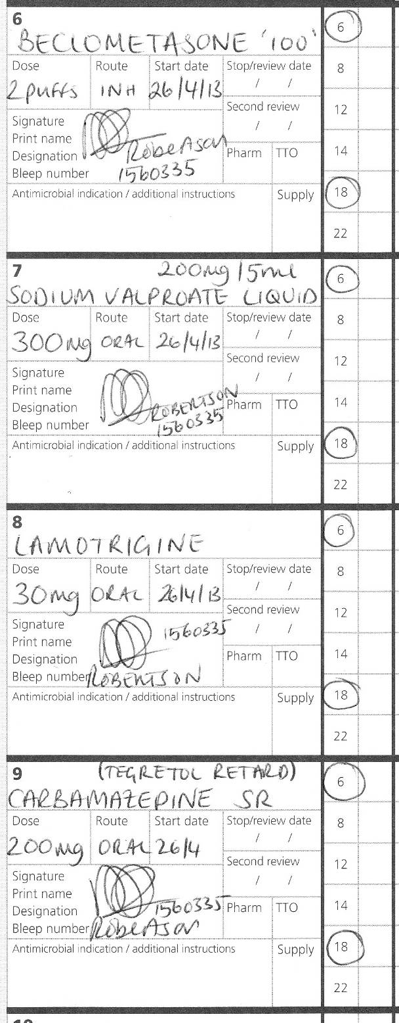

Exercise 3 - Infusion Prescription

From the IV monograph:
Dilute 1mg/kg of morphine to 50ml with sodium chloride 0.9%.

At this concentration: 0.5 – 3ml/hr Ξ 10 – 60 mcg/kg/hr

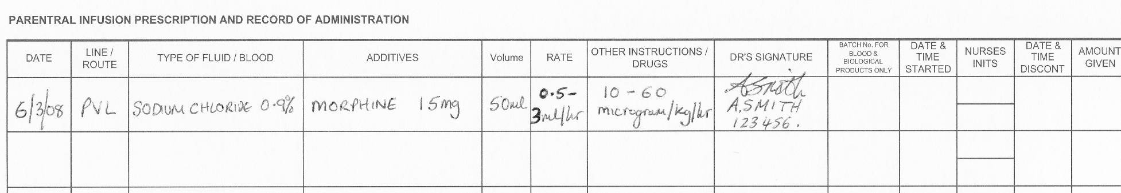
Exercise 4 – Diabetic Ketoacidosis

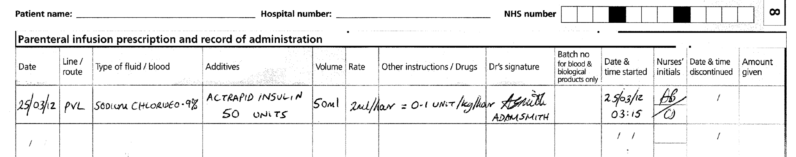

When prescribing insulin the word ‘units’ must be written in full. There have been incidents where the dose has been expressed as ‘u’ e.g. 50u and the prescription misread as 500 units with ten times the dose having been administered. Ensure that the rate in ml/hr is specified and matches the rate in units/kg/hour
When treating a child with DKA, please follow the pathway document and clinical guideline as this will provide details on how to calculate and prescribe fluids and insulin for this patient group.

When prescribing a patients usual insulin, please include details of the insulin formulation e.g. pre-filled pen, vial
Exercise 5 – Intravenous Fluids

Maintenance fluid requirements for paediatric patients over 1 month of age can be calculated as: -

Body Weight | 24-hour fluid requirement
Under 10kg | 100ml/kg
10-20kg | 100ml/kg for the first 10kg  + 50ml/kg for each 1kg body-weight over 10kg
Over 20kg | 100ml/kg for the first 10kg  + 50ml/kg for each 1kg body-weight between 10-20kg  + 20ml/kg for each 1kg body-weight over 20kg  (max 2 litres in females and 2.5 litres in males

a) A 15 kg child is discharged from PICU and needs fluid overnight.

- What is the daily fluid requirement?

1250ml

- What is the hourly rate?

52ml/hour

She is recovering from pneumonia and is fluid restricted to 70% maintenance

- What is the restricted daily amount?

875ml

- What is the restricted hourly rate?

36ml/hour

- What fluid would you use?

2.5% dextrose (or 5%) and 0.45% saline (with potassium if recent EC are normal)

- A 5 day 3.6kg baby is admitted with sepsis and poor feeding. He needs iv fluids overnight.

  - What is the daily fluid requirement?

360ml

Milk feed and TPN volumes are often calculated at:
Day 1 – 60 ml/kg/d
Day 2 – 90 ml/kg/d
Day 3 – 120 ml/kg/d
Day 4 onwards – 150 ml/kg/d
If on IV fluids babies usually do not need above 100ml/kg/d, if you are uncertain please discuss with your senior colleague.

  - What is the hourly rate?

15ml/hour

  - What fluid would you prescribe?

10% dextrose (and consider adding electrolytes when EC available)

- The following day the EC results come back for the same septic baby (from part b). Your Consultant asks you to add 3mmol/kg/d of sodium and 2mmol/kg/d of potassium to the IV fluids.

  - How much sodium chloride do you add to a 500ml bag?

15 mmol

  - How much potassium chloride do you add to a 500ml bag?

10 mmol

- A 28kg child is awaiting theatre and needs pre-op fluids.

  - What is the daily fluid requirement?

1660ml

  - What is the hourly rate?

69ml/hour

  - What fluid would you prescribe?

0.45 saline/2.5% dextrose (with potassium if EC ok)

He starts vomiting and is put on free NG drainage. The surgeons ask you to prescribe ml for ml replacement fluids.

  - What fluid would you use?

Sodium Chloride 0.9% + Potassium Chloride 10mmol (500ml)

  - How would you prescribe this?

ml for ml replacement of hourly NG losses

Exercise 6 - Maths Test

1. A three day old baby is treated with 15mg of phenytoin intravenously. The ampoule contains 50mg/ml. The baby should receive 0.3 mls.

2. An infant is to receive 0.3g of calcium gluconate intravenously. The solution contains 10% calcium gluconate. The infant should receive 3 ml.
A 10% solution contains 10g in 100ml. This equals 1g in 10mls and 0.1g in 1ml. 0.3g is therefore 3ml.

3. A two month old baby is prescribed 0.3ml of phenobarbitone for seizures. The ampoule contains 30mg/ml. She was given 3mls by mistake. How many milligrams were given? 90 mg

4. A child weighs 74 pounds. How many kilograms does he weigh? 33.6 kg

5. How many grams of mannitol does 10ml of a 20% mannitol solution contain? 2 grams

6. 0.1mg is how many micrograms? 100 micrograms

7. At a cardiac arrest, a child requires 100microgram/kg of adrenaline. He weighs 12kg, and you have ampoules of adrenaline 1 in 1,000. How many mls should you give? 1.2mls (1 in 1,000 solution is equivalent to 1mg/ml)

8. A dopamine infusion is required for a child weighing 20kg. You put 200mg in 50ml of normal saline, and want to give a dose of 5micrograms/kg/minute. How many mls per hour should the infusion be started at? 1.5mls/hour.
IV monographs are available to help you with prescribing IV infusions. Using standard infusions is safer than ‘doing your own thing’, and if non-standard solutions are made up (for instance if the patient is fluid restricted) it should be clearly marked as such.

