WORKBOOK ON SAFER PRESCRIBING FOR PAEDIATRIC DOCTORS

VERSION 2.0

NAME ………………………………………


Before you start:
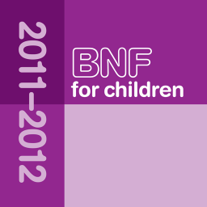
Do you carry a smartphone at work?

You can download the FREE ‘BNF for Children’ app

Why not do it NOW?
Why has this workbook been produced?

Medical errors receive a great deal of attention, with many policy initiatives implemented to reduce the incidence of these errors. Medication errors are probably the commonest type of medical error. In UK hospitals, prescribing errors occur in 1.5% of prescriptions, and administration errors occur in 3-8% of doses given¹ (probably an underestimate). The National Patient Safety Agency reported 10,000 incidents relating to prescribing between Jan 2005 and June 2006, of which children aged up to 4 years were involved in more than 10% of these incidents where age was stated².

Paediatric prescribing and administration has a high risk of medication errors occurring. This is due to several reasons:-
- Dose calculations, based on weight, age or body surface area. – For potent drugs it is easy to cause a 10 fold or more dosing error due to miscalculation or misplacement of the decimal point. Weight ranges can vary from the 500gram neonate to an 80kg adolescent.
- Licensing status of the drug – many drugs are either unlicensed or used off label (outside the terms of the product licence), where there may not be sufficient dosing information available.
- Formulations – Many formulations used in children have been designed for adult use. e.g. use of morphine injection 10mg could potentially result in a huge overdose for babies and young infants.
- Lack of standardisation – Preparations, such as suspensions, which have to be made up individually (due to lack of a commercial product being available), may result in a child being supplied one strength of suspension from their local pharmacy and a different strength of suspension from the hospital pharmacy when admitted to hospital.

Medication errors lead to harm in up to 1-2% of adult patients admitted to hospital in the UK and US^{3, 4}. However, errors in paediatrics are more likely to lead to harm⁵.

Locally all paediatric medication errors, including prescribing errors, are increasing:

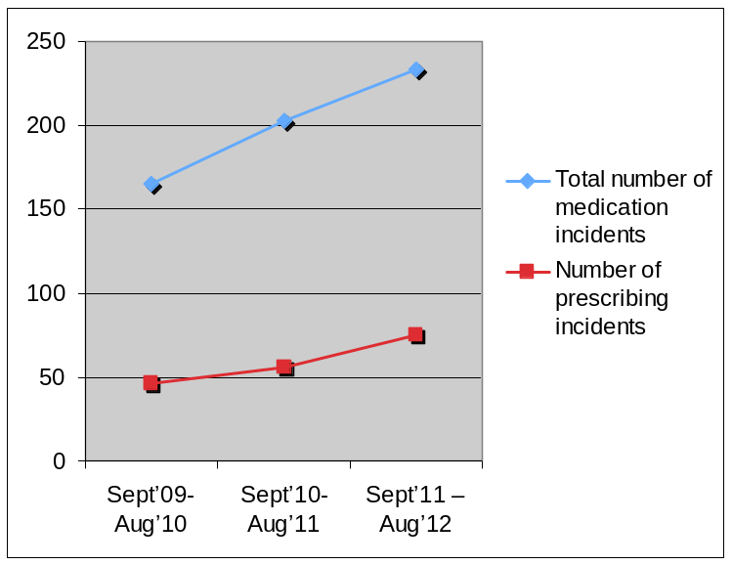
Of these the commonest /most serious were:
  - Wrong dose – 38%
- e.g. calculation error, oral dose used for IV / PR administration or adult dose prescribed
  - Wrong timing or frequency – 12%
  - Inaccurate TTOs – 8%
  - Wrong unit – 6%
  - Patients’ regular medications not prescribed on admission – 6%
  - Duplicated prescriptions – 6%
- e.g. 2 different NSAIDs, same drug in different places (drug chart v. anaesthetic record v. ED notes)
  - Contraindication / allergy – 4%

Three groups will be affected by drug errors that occur: -
The patient: Adverse drug errors only rarely cause death, but they can cause significant morbidity e.g. deafness and ototoxicty from a gentamicin overdose. In addition the patients stay in hospital can also be prolonged.
The Trust: Drug errors can cause complaints from patients. Settling these complaints is costly and time consuming.
The prescriber: Serious drug errors can result in investigation by the police and the GMC. It is probably not possible to be error free, but it is possible to reduce the chances of errors occurring.

References
- Ghaleb MA, Wong ICK. Medication errors in paediatric patients. Arch Dis Child Educ Pract Ed 2006;91:ep20-ep24
- Sammons H, Conroy S. How do we ensure safe prescribing for children? Arch Dis Child 2008;93:98-99
- Department of Health. An organization with a memory. London: The Stationery Office, 2000.
- Department of Health. Building a safer NHS: Implementing an organisation with a memory. London: The Stationery Office, 2001.
- Kaushal R, Bates DW, Landrigan C, et al. Medication errors and adverse drug events in pediatric inpatients. JAMA 2001;285:2114–20.

What does this workbook contain?

This prescribing workbook aims to raise awareness of the Trust Prescribing policy and good practice when prescribing medication. The workbook contains a number of exercises relating to prescribing medication and calculation doses in children. The workbook is not designed to catch you out, but should be used as a tool to improve your prescribing skills.

What do I do with this workbook?

This workbook is compulsory for all junior medical staff working in paediatrics. Please complete it on your own and bring it to your induction.

What happens once I have completed it?

You will mark the workbook at induction using a model answer book and have a chance to talk it through with your colleagues and a pharmacist.

What can I do to help reduce the incidence of prescribing errors?

The following page provides information on how medicines must be prescribed. Usually serious drug incidents are as a result of a catalogue of small errors, rather than the fault of one particular person. By reporting errors and near miss events, procedures can be put in place that will reduce the likelihood of them happening again. Please ensure that a Critical Incident Report form is completed for any medication incidents you are aware of.

If a prescribing error is identified to which you have contributed you will be asked to complete a reflective summary on your ePortfolio and to review this with your Educational Supervisor. This will help you to contribute towards finding a solution that will benefit the whole department and is not intended to be punitive. It is good practice and useful managerial experience to participate in this type of quality improvement work.

Where do I go to get more information?

Please feel free to approach any of the paediatric pharmacists. You may also find it useful to discuss incidents with your colleagues.
How to prescribe medication for children

- Follow the Trust Prescribing guidelines

  - Use an addressograph to ensure that the patients Name, Hospital number and Date of Birth are on the prescription.

  - Ensure that the child’s weight is written on the prescription. If a weight is amended it is good practice to date the new weight.

  - The Drug Allergies box MUST be completed, even if the child has no allergies. It is also useful to include details of any food allergies.

  - Approved generic drug names MUST be used, with the name written in Capitals.

  - Correct dosage units MUST be used. Write micrograms in full (rather than mcg or μg), and also write nanograms in full.

  - DO NOT use Roman numerals when prescribing.

  - Do not use abbreviations. E.g. write Potassium Chloride in full and not as KCl.

  - Prescriptions for liquid medicines MUST have the dose written by weight of the drug (in milligrams, micrograms etc), and not prescribed just as mls.

  - For PRN drugs the maximum frequency must be indicated.

  - Ensure that when the use of a decimal point is unavoidable, that the decimal point is clear and where relevant, that the decimal point is preceded by a zero e.g. Dalivit 0.6ml not .6ml.

  - If a change needs to be made to a drug, the drug must be rewritten in full again and the original prescription crossed out, signed and dated.

  - When rewriting charts ensure that the start date of the drug is carried forward (particularly for defined courses of medication).

  - All antibiotics should have an indication and a completed stop / review date (which should be acted upon in a timely fashion)
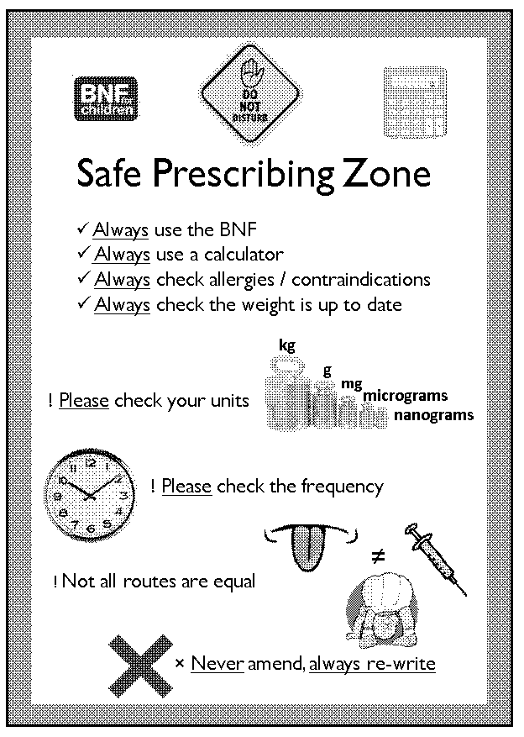

- Use the designated ‘Safe Prescribing Zone’ on each ward

- You should not be interrupted here

- You will find a BNFc and calculator here
  - Use them even if you think you know the dose

- ‘Top Tips’ will remind you how to avoid the commonest and
most serious errors
Exercise 1

- Please review the prescription chart on the following pages and then answer the questions on the pages that follow.
- Remember to think about what you have read so far in this document and how these prescriptions compare with your own prescribing practice.

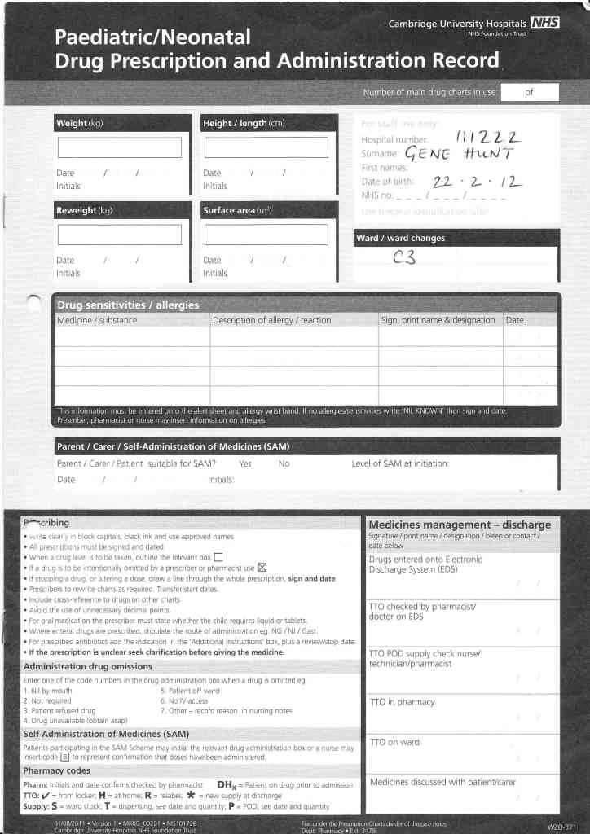
Exercise 1
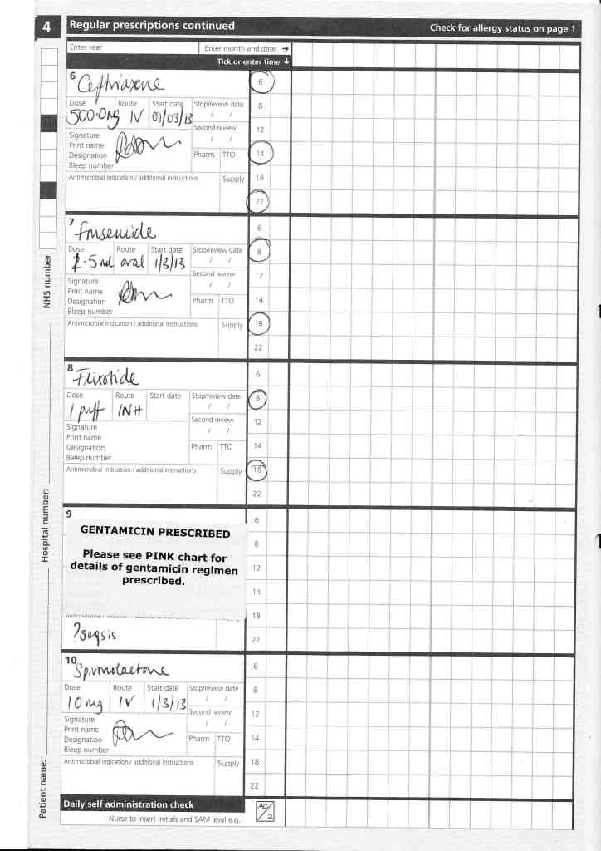
Exercise 1

- Please list three errors on the front page of the prescription chart:

a) ………………………………………………………………..

b) ………………………………………………………………..

c) …………………………………………………………………

- Original prescription:

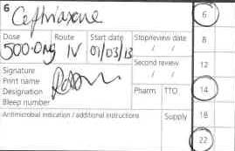

The errors on this prescription are:

a) ………………………………………………………………..

b) ………………………………………………………………..

c) ………………………………………………………………..

d) ………………………………………………………………..

e) ………………………………………………………………..

f) ………………………………………………………………..

g) ………………………………………………………………..

Please rewrite the prescription correctly in the box below:

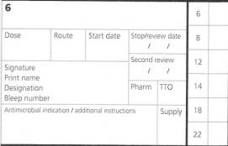

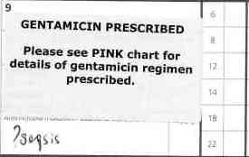
- Original prescription:

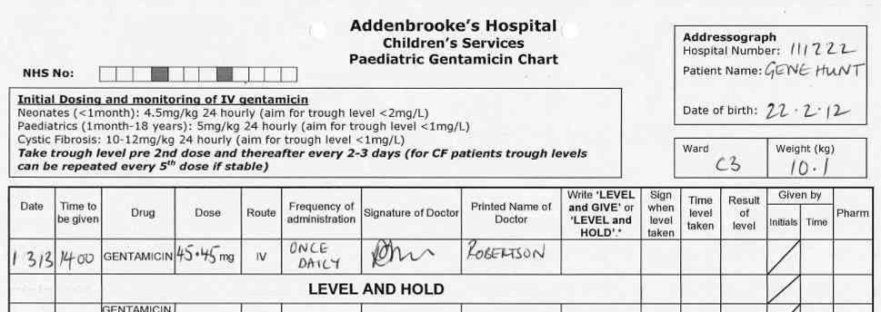

The errors on this prescription are:

a) ………………………………………………………………..

b) ………………………………………………………………..

c) ………………………………………………………………..

d) ………………………………………………………………..

e) ………………………………………………………………..

Please rewrite the prescription correctly on the chart below:

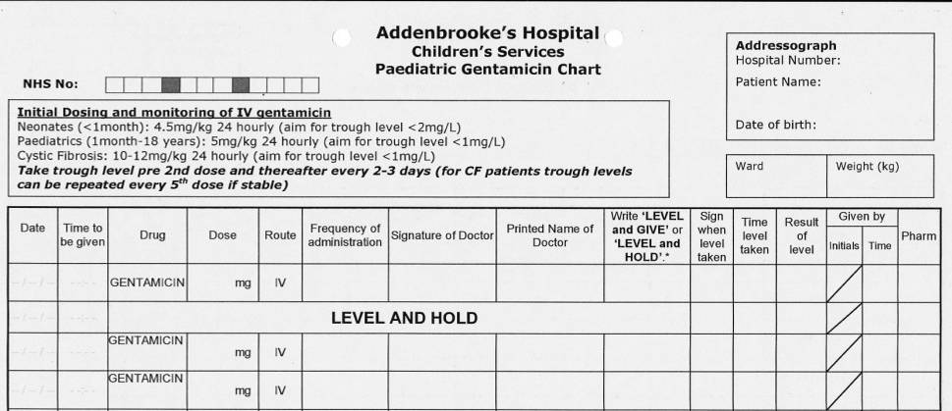

Original prescription:

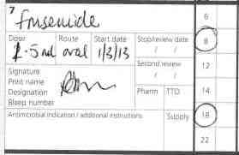

The errors on this prescription are:

  - ………………………………………………………………..

  - ………………………………………………………………..

  - ………………………………………………………………..

  - ………………………………………………………………..

Please rewrite the prescription correctly in the box below:

5. Original prescription:
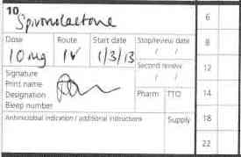

The errors on this prescription are:

a) ………………………………………………………………..

b) ………………………………………………………………..

c) ………………………………………………………………..

d) ………………………………………………………………..

e) ………………………………………………………………..

Please rewrite the prescription correctly in the box below:

6. Original prescription:
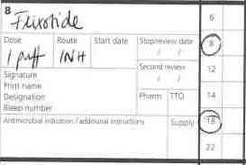

The errors on this prescription are:

a) ………………………………………………………………..

b) ………………………………………………………………..

c) ………………………………………………………………..

d) ………………………………………………………………..

e) ………………………………………………………………..

Please rewrite the prescription correctly in the box below: -

Exercise 2 – Prescribing medication on admission

One of the tasks which is often carried out by junior doctors is the prescribing of patient’s own drugs on admission.

Please prescribe the following medications onto the drug chart (page 13)

SHAKE THE CANNISTER
CLENIL MODULITE Inhaler
100micrograms per metered dose

Inhale TWO puffs TWICE a day
Do not stop taking this medicine except on your doctor’s advice

BILLY REUBIN 25-MAR 2013

SHAKE THE CANNISTER
VENTOLIN Inhaler
100micrograms per metered dose

Inhale TWO puffs when necessary

BILLY REUBIN 25-MAR 2013

SHAKE THE BOTTLE
EPILIM Sugar-Free Liquid
200mg in 5ml

Take 7.5ml TWICE a day

Do not stop taking this medicine except on your doctor’s advice

300ml BILLY REUBIN 25-MAR 2013

LAMOTRIGINE
25mg tablets

Take ONE tablet TWICE a day

Do not stop taking this medicine except on your doctor’s advice

56 BILLY REUBIN 25-MAR 2013

LAMOTRIGINE
5mg tablets

Take ONE tablet TWICE a day

Do not stop taking this medicine except on your doctor’s advice

56 BILLY REUBIN 25-MAR 2013

TEGRETOL RETARD
200mg tablets

Take ONE tablet TWICE a day

Swallow tablet(s) whole, do not chew

56 BILLY REUBIN 25-MAR 2013

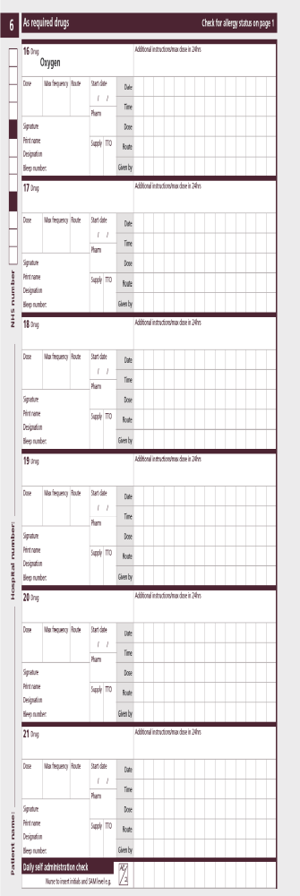
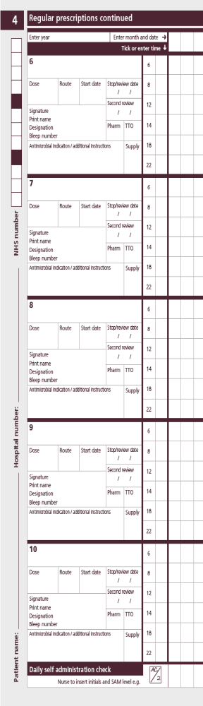
EXERCISE 3 – DRUG INFUSIONS

In the space below, please write up an infusion for Morphine, using sodium Chloride 0.9% as the diluent.
The child’s weight is 15kg.
You can find information on prescribing IV morphine in the IV monographs which are kept in clinical areas and are available on-line at Connect.

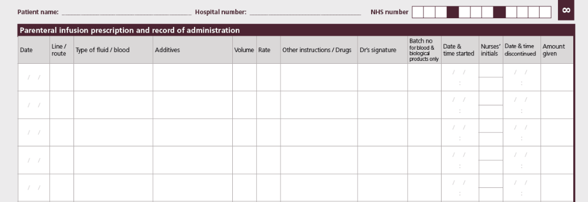
Exercise 4 – Diabetic Ketoacidosis

You are asked to prescribe an actrapid insulin infusion for a 20kg child who has Diabetic Ketoacidosis. The infusion needs to run at 0.1unit/kg/hour. You can get information to help you with prescribing with DKA patients by following the DKA pathway for children. Please prescribe your infusion on the prescription chart below.

Exercise 5 – Intravenous fluids

a) A 15 kg child is discharged from PICU and needs fluid overnight.

- What is the daily fluid requirement?
- What is the hourly rate?

She is recovering from pneumonia and is fluid restricted to 70% maintenance

- What is the restricted daily amount?
- What is the restricted hourly rate?
- What fluid would you use?

- A 5 day 3.6kg baby is admitted with sepsis and poor feeding. He needs iv fluids overnight.

  - What is the daily fluid requirement?
  - What is the hourly rate?
  - What fluid would you prescribe?

- The following day the EC results come back for the same septic baby (from part b). Your Consultant asks you to add 3mmol/kg/d of sodium and 2mmol/kg/d of potassium to the IV fluids.

- How much sodium chloride do you add to a 500ml bag?
- How much potassium chloride do you add to a 500ml bag?

- A 28kg child is awaiting theatre and needs pre-op fluids.

  - What is the daily fluid requirement?
  - What is the hourly rate?
  - What fluid would you prescribe?

He starts vomiting and is put on free NG drainage. The surgeons ask you to prescribe ml for ml replacement fluids.

  - What fluid would you use?
  - How would you prescribe this?

Exercise 5 – Maths Test

Please make the following dose calculations. Use a calculator or any other means you routinely use. If you have any comments about any of the doses, please write them in the ‘comments’ section.

1. A three day old baby is treated with 15mg of phenytoin intravenously. The ampoule contains 50mg/ml. The baby should receive ……mls.

2. An infant is to receive 0.3g of calcium gluconate intravenously. The solution contains 10% calcium gluconate. The infant should receive ……ml.

3. A two month old baby is prescribed 0.3ml of phenobarbitone for seizures. She was given 3mls by mistake. The ampoule contains 30mg/ml. How many milligrams were given? …….mg

4. A child weighs 74 pounds. How many kilograms does he weigh? ……kg

5. How many grams of mannitol does 10ml of a 20% mannitol solution contain? ……gm

6. 0.1mg is how many micrograms? ……micrograms

7. At a cardiac arrest, a child requires 100microgram/kg of adrenaline. He weighs 12kg, and you have ampoules of adrenaline 1 in 1,000. How many mls should you give? ……mls

8. A dopamine infusion is required for a child weighing 20kg. You put 200mg in 50ml of normal saline, and want to give a dose of 5microgms/kg/minute. How many mls per hour should the infusion be started at? ………mls/hour.
Any comments about the above questions:

